The History of the iPhone

How has Apple's popular smartphone evolved in the past three years?
by Jesse Schedeen
June 24, 2010
Apple recently debuted the iPhone 4, its newest iteration of the mega-popular smartphone. June 24 is the day the iPhone officially hits the Apple Store and other retailers. Fans were lined up around the block in the wee hours of the morning in hopes of getting their hands on this coveted device. The luckier among them were successful.
Whether you're taking your new iPhone for a test drive or moping because you missed out, we have something to help keep you occupied. In this History of the iPhone feature, we trace the evolution of the device from the original model through the 3G and 3GS upgrades all the way to the new iPhone 4. We examine what features have changed and how Apple has responded to consumer demands over the past three years.
Be sure to let us know your thoughts on the iPhone 4 by posting in the comments section below.
iPhone
Release date: June 29, 2007
Storage capacity: 4 GB, 8 GB (16 GB model added later)
Operating system: iOS 1.0
Rated battery life: 24 hours audio, 7 hours video, 6 hours Internet browsing, 8 hours talk time
Notable features: Multi-touch screen, Wi-Fi & cellular Internet access, 2 MP camera
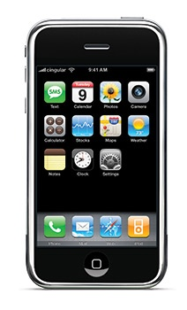
Rumors had persisted for years of a touch-based iPod, one whose screen covered the entire front of the device and featured no tactile buttons. Speculation was finally confirmed in the form of the original iPhone, which debuted in June 2007. To the surprise of many Apple fans, though, the long-rumored device wasn't just an iPod, but a full-fledged phone and multimedia device.
The most immediately distinctive feature of the device was its touch screen. Whereas many fans pictured a touch-based take on the familiar iPod scroll wheel, the iPhone instead offered a multi-touch screen developed by Finger Works. Compared to a device like the Nintendo DS, which only recognizes one point of contact at a time, users can touch the iPhone screen at multiple points at once, allowing for features like dragging and highlighting. The screen was protected by a glass coating rather than the traditional hard plastic.
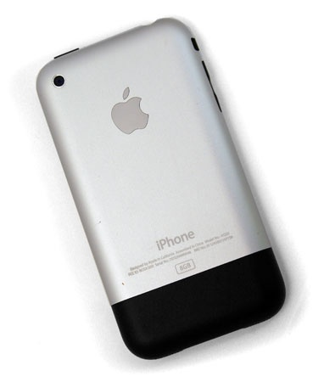
This original iPhone offered a design scheme that was closely followed in later models. The touchscreen eliminated the need for many tactile buttons. Only the home button, volume buttons, and a handful of others were built into the device. The iPhone featured a chrome metal frame, but the rear of the device was made of a mixture plastic and aluminum in order to prevent the chrome from dampening cellular and wireless signals.
Internally, the iPhone featured a Samsung 32-bit RISC ARM processor with a maximum speed of 620 MHz, though the processor was under clocked out of the box. The Power VR MBX Lite 3d graphics processor, coupled with the high resolution 320x480 resolution screen, allowed for both gaming and video watching. The iPhone also included a 2.0 megapixel camera.
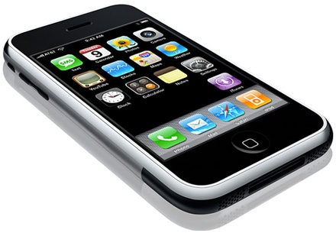
The original iPhone was the first to feature Apple's new iOS operating system, an OS designed specifically for small mobile devices. iOS was designed as a scaled-down version of Apple's OSX system, and in fact, the iPhone was originally said to be running OSX 10. Only after introducing support for third-party development did Apple officially dub the iPhone's OS iOS 1.0.
The iPhone offered quad-band GSM capability, with cellular support provided by AT&T. The device also supported Wi-Fi access (both 802.11 b and g) and Bluetooth 2.0. iPhone cellular support was and still is limited to AT&T, which proved to be a sore point with some consumers not satisfied with AT&T's cellular coverage. Though consumers were able to purchase unlocked iPhones at a considerably higher price, the phones were still only compatible with AT&T's network.
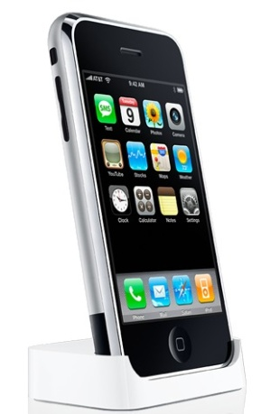
Originally the iPhone came in 4 GB and 8 GB flash memory capacities. However, the debut of the first iPod Touch in September 2007 saw Apple discontinue the 4 GB model and drop the price of the 8 GB version significantly. The following spring, Apple introduced a 16 GB model alongside the new iOS 2.0. This would be the last physical upgrade to the original iPhone model, though the device continued to support iOS up to version 3.13.
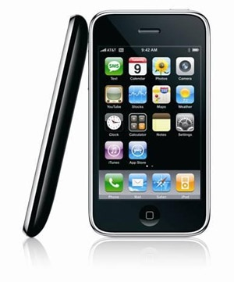
Apple has a history of releasing annual updates to its various iPod models. That trend has continued unabated with the iPhone as well. A little more than a year after the original iPhone hit stores, and mere months after the introduction of the iOS 2.0, Apple was back with the second iPhone iteration – the iPhone 3G.
The most significant upgrade is made apparent by the device's name. Apple added 3G cellular support to its device, greatly boosting wireless performance outside of Wi-Fi hotspots. This 3G support addressed one of the central criticisms of the original model. However, service was still limited to AT&T only. The iPhone 3G retained quad-band GSM support, but also added tri-band UMTS for international users and Assisted GPS support.
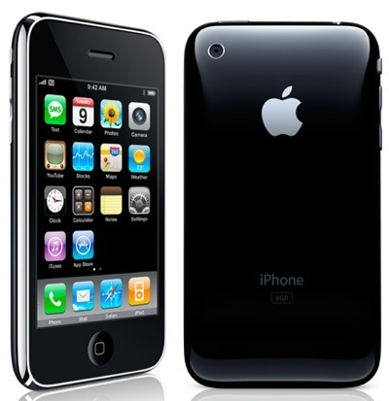
Externally, the iPhone 3G saw a number of small changes. The basic rounded shape remained, though the ends became slightly tapered to allow for easier gripping. The aluminum/plastic backside of the unit was replaced by a glossy plastic section. In addition to cutting costs, the plastic also allowed consumers to have their choice of white or black iPhone variants. The button layout remained identical, but the actual dimensions of the iPhone were reduced slightly to make it more portable. Storage capacities also remained set at 8 GB and 16 GB.
Aside from 3G support, the internal components of the iPhone 3G changed little from its predecessor. It included the same Samsung-designed RISC ARM processor and Power VR graphics chipset. The 320x480 pixel screen also remained identical. Coupled with the same 128 MB eDRAM memory, the iPhone began to lag behind competing smartphones in terms of performance. Even Apple's iPod Touch offered better performance in games and other memory-intensive programs.
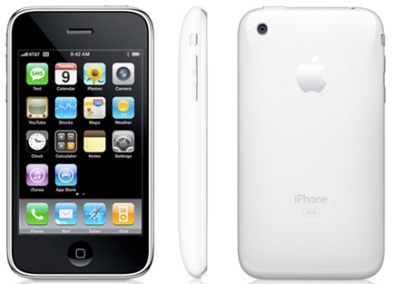
Apple's iOS 2.0 had already been introduced for the original iPhone, but it shipped standard o the 3G. Like the first iPhone, the 3G remained forwards-compatible with future versions of iOS. Where the original iPhone is incapable of running the new iOS 4.0, the 3G offers limited support. IOS 3.1.3 remains the most recent stable software for the 3G.
iPhone 3GS
Release date: June 19, 2009
Storage capacity: 16 GB & 32 GB
Operating system: iOS 3.0
Rated battery life: 30 hours audio, 10 hours video, 9 hours Internet browsing, 10 hours talk time (2G), 5 hours talk time (3G)
Notable features: More RAM & faster processor, video camera, voice control
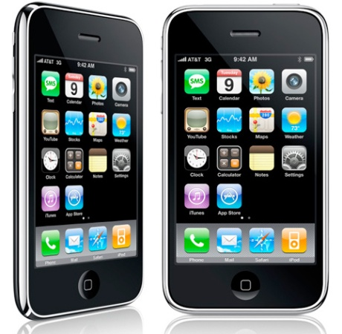
Once again, Apple followed up on the iPhone with a new model roughly one year later. The iPhone 3GS was arguably the least significant upgrade of the four models, as its changes were more intended to boost performance and provide a few much-request features.
The internal specs of the iPhone saw a number of improvements with the 3GS model. The eDRAM was doubled from 128 MB to 256 MB. A new Samsung S5PC100 ARM processor offered a top speed of 800 MHz, though it too was underclocked out of the box. Nevertheless, these improvements allowed for faster performance with memory-intensive applications and games and put the iPhone's performance more in line with the newer iPod Touch models. Battery life was also improved over previous models.
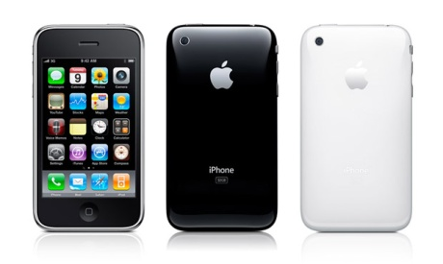
Apple also doubled the available storage capacities, discontinuing the 8GB model and adding a 32 GB version instead. This allowed for more multimedia storage, though some users lamented the lack of a 64 GB model to accompany the 64 GB iPod Touch.
The camera also saw an upgrade from 2.0 megapixels to 3.0 MP. Even more significant was the introduction of video recording capabilities. The 3GS was capable of SD video capture at 640x480 resolution and also included an auto-focus feature for the first time. One feature the camera still lacked was a flash.
In terms of wireless connectivity, the 3GS remained unaltered. It still offered quad-band GSM and tri-band UMTS for 3G users, as well as the standard 802.11 b and g Wi-Fi options and Bluetooth 2.0 support.
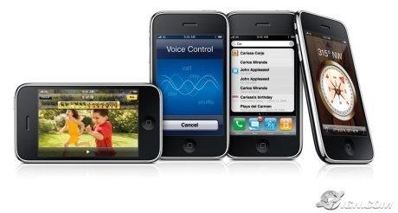
Externally, the 3GS appeared nearly identical to the 3G. The dimensions of the phone, as well as the general tapered design, remained unchanged. The 3GS retained the glossy plastic back plate, with only the reflective silver text on the back denoting the change. Color choices remained limited to black and white. Interestingly, owners of the white 3GS found themselves at a slight disadvantage. The 3GS showed a tendency to overheat when users ran bot the 3G and GPS functions simultaneously. Reports circulated that white iPhone models became discolored thanks to the overheating.
As usual, the new iPhone came included with Apple's newest iOS version standard. The 3GS offered iOS 3.0. Notable additions to this version of iOS included MMS messaging and support for cutting and pasting text
Another year, another iPhone. That may have been the thinking with many Apple fans before the iPhone 4 was unveiled. After two years of upgrades that were more evolutionary than revolutionary, fans were waiting for the iPhone to pull ahead of the smartphone pack again.
While most assumed Apple would stick to their trend of unveiling the new iPhone in June or July, first details on the iPhone 4 leaked months early. A prototype model was found in a bar, purportedly left behind by an Apple employee. This new iPhone sported a slimmer, more industrial design and a screen that was clearly a huge leap from the familiar 320x480 screen of the older iPhone models. The only question was whether this leaked model was the real deal or a very elaborate hoax.
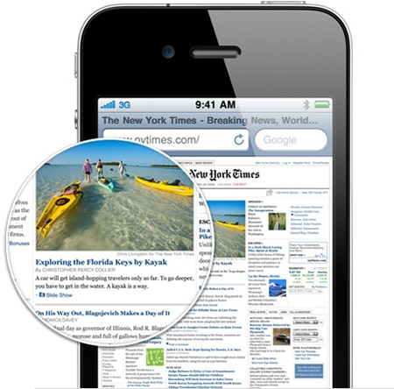
When Steve Jobs took the stage at Apple's WWDC 2010 conference, it became apparent that the iPhone 4 was no hoax. This new model is indeed a significant departure from past models in nearly all respects. Gone is the smooth, tapered design of the 3G and 3GS. The iPhone 4.0 is longer, thinner, and much more flat. Instead of a plastic back plate, the iPhone is now coated by an aluminosilicate glass covering on both the front and back sides. Jobs claims this new form of glass is far more durable and scratch-resistant, though early tests show it to be very fingerprint-prone. The sides of the iPhone are now coated by a stainless steel frame, which is actually the iPhone's antenna receiver. Apple's hope is that this internal antenna setup will reduce wireless interference and boost performance for both 3G and Wi-Fi functions.
The screen is indeed improved over past iPhone models. The iPhone 4 boasts a 960x640 pixel resolution display with an 800:1 contrast ratio. The iPhone is now capable of displaying true 720p video, and in fact, early rumors suggested it would be called the "iPhone HD".
Driving this new iPhone is a new Apple A4 ARM Cortex A8procesor that clocks in at 1 GHz. This is the same processor featured in the iPad. The iPhone's eDRAM has been doubled again to 512 MB. The switch from a standard SIM card to a microSIM allows more internal space to be devoted to the battery, resulting in boosted battery length as well. Storage capacity remains unchanged at 16 GB and 32 GB.
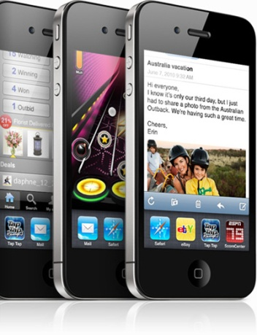
These new specs come in handy when driving Apple's newest iteration of iOS. IOS 4.0 adds a highly requested feature – multitasking. While previous iPhones allowed users to run basic functions like music playback in the background while browsing the Internet, iOS 4.0 allows multiple third-party applications to be run simultaneously. The OS supports a maximum of seven active apps at a given time.
The multitasking feature gives the iPhone 4 an advantage even over the iPad. Apple has announced its intention to adapt iOS 4.0 for the iPad, but for now the device lacks multitasking functionality.
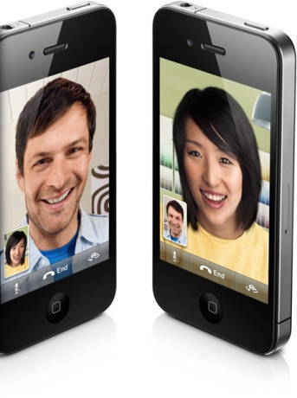
The iPhone's camera has also received a significant upgrade in this new model. The iPhone 4 actually features two separate camera. In addition to a front-facing VGA camera, a new rear-facing 5.0 megapixel camera has been added. This camera includes both a digital zoom and an LED flash function, both features previous iPhone cameras lacked. The rear-facing camera is capable of capturing 720p HD video at 30 frames-per-second. Apple has also introduced its Face Time videoconferencing feature alongside the iPhone 4.
One rumor about the iPhone 4 that didn't pan out is the idea of Apple making the phone available to other cellular providers. Numerous websites reported that Apple was prepared to bring the iPhone 4 to Verizon. For the time being, however, AT&T remains the only provider that supports the iPhone.
That's the history of the iPhone so far. Given the continued popularity of Apple's smart phone, we can only assume a fifth model will debut next summer. Stay tuned to IGN Gear throughout the year for more iPhone and iPod coverage as news hits.
http://www.ign.com/articles/2010/06/24/the-history-of-the-iphone?

